Importing the dataset and loading it from the csv to xslx format
1. Load data
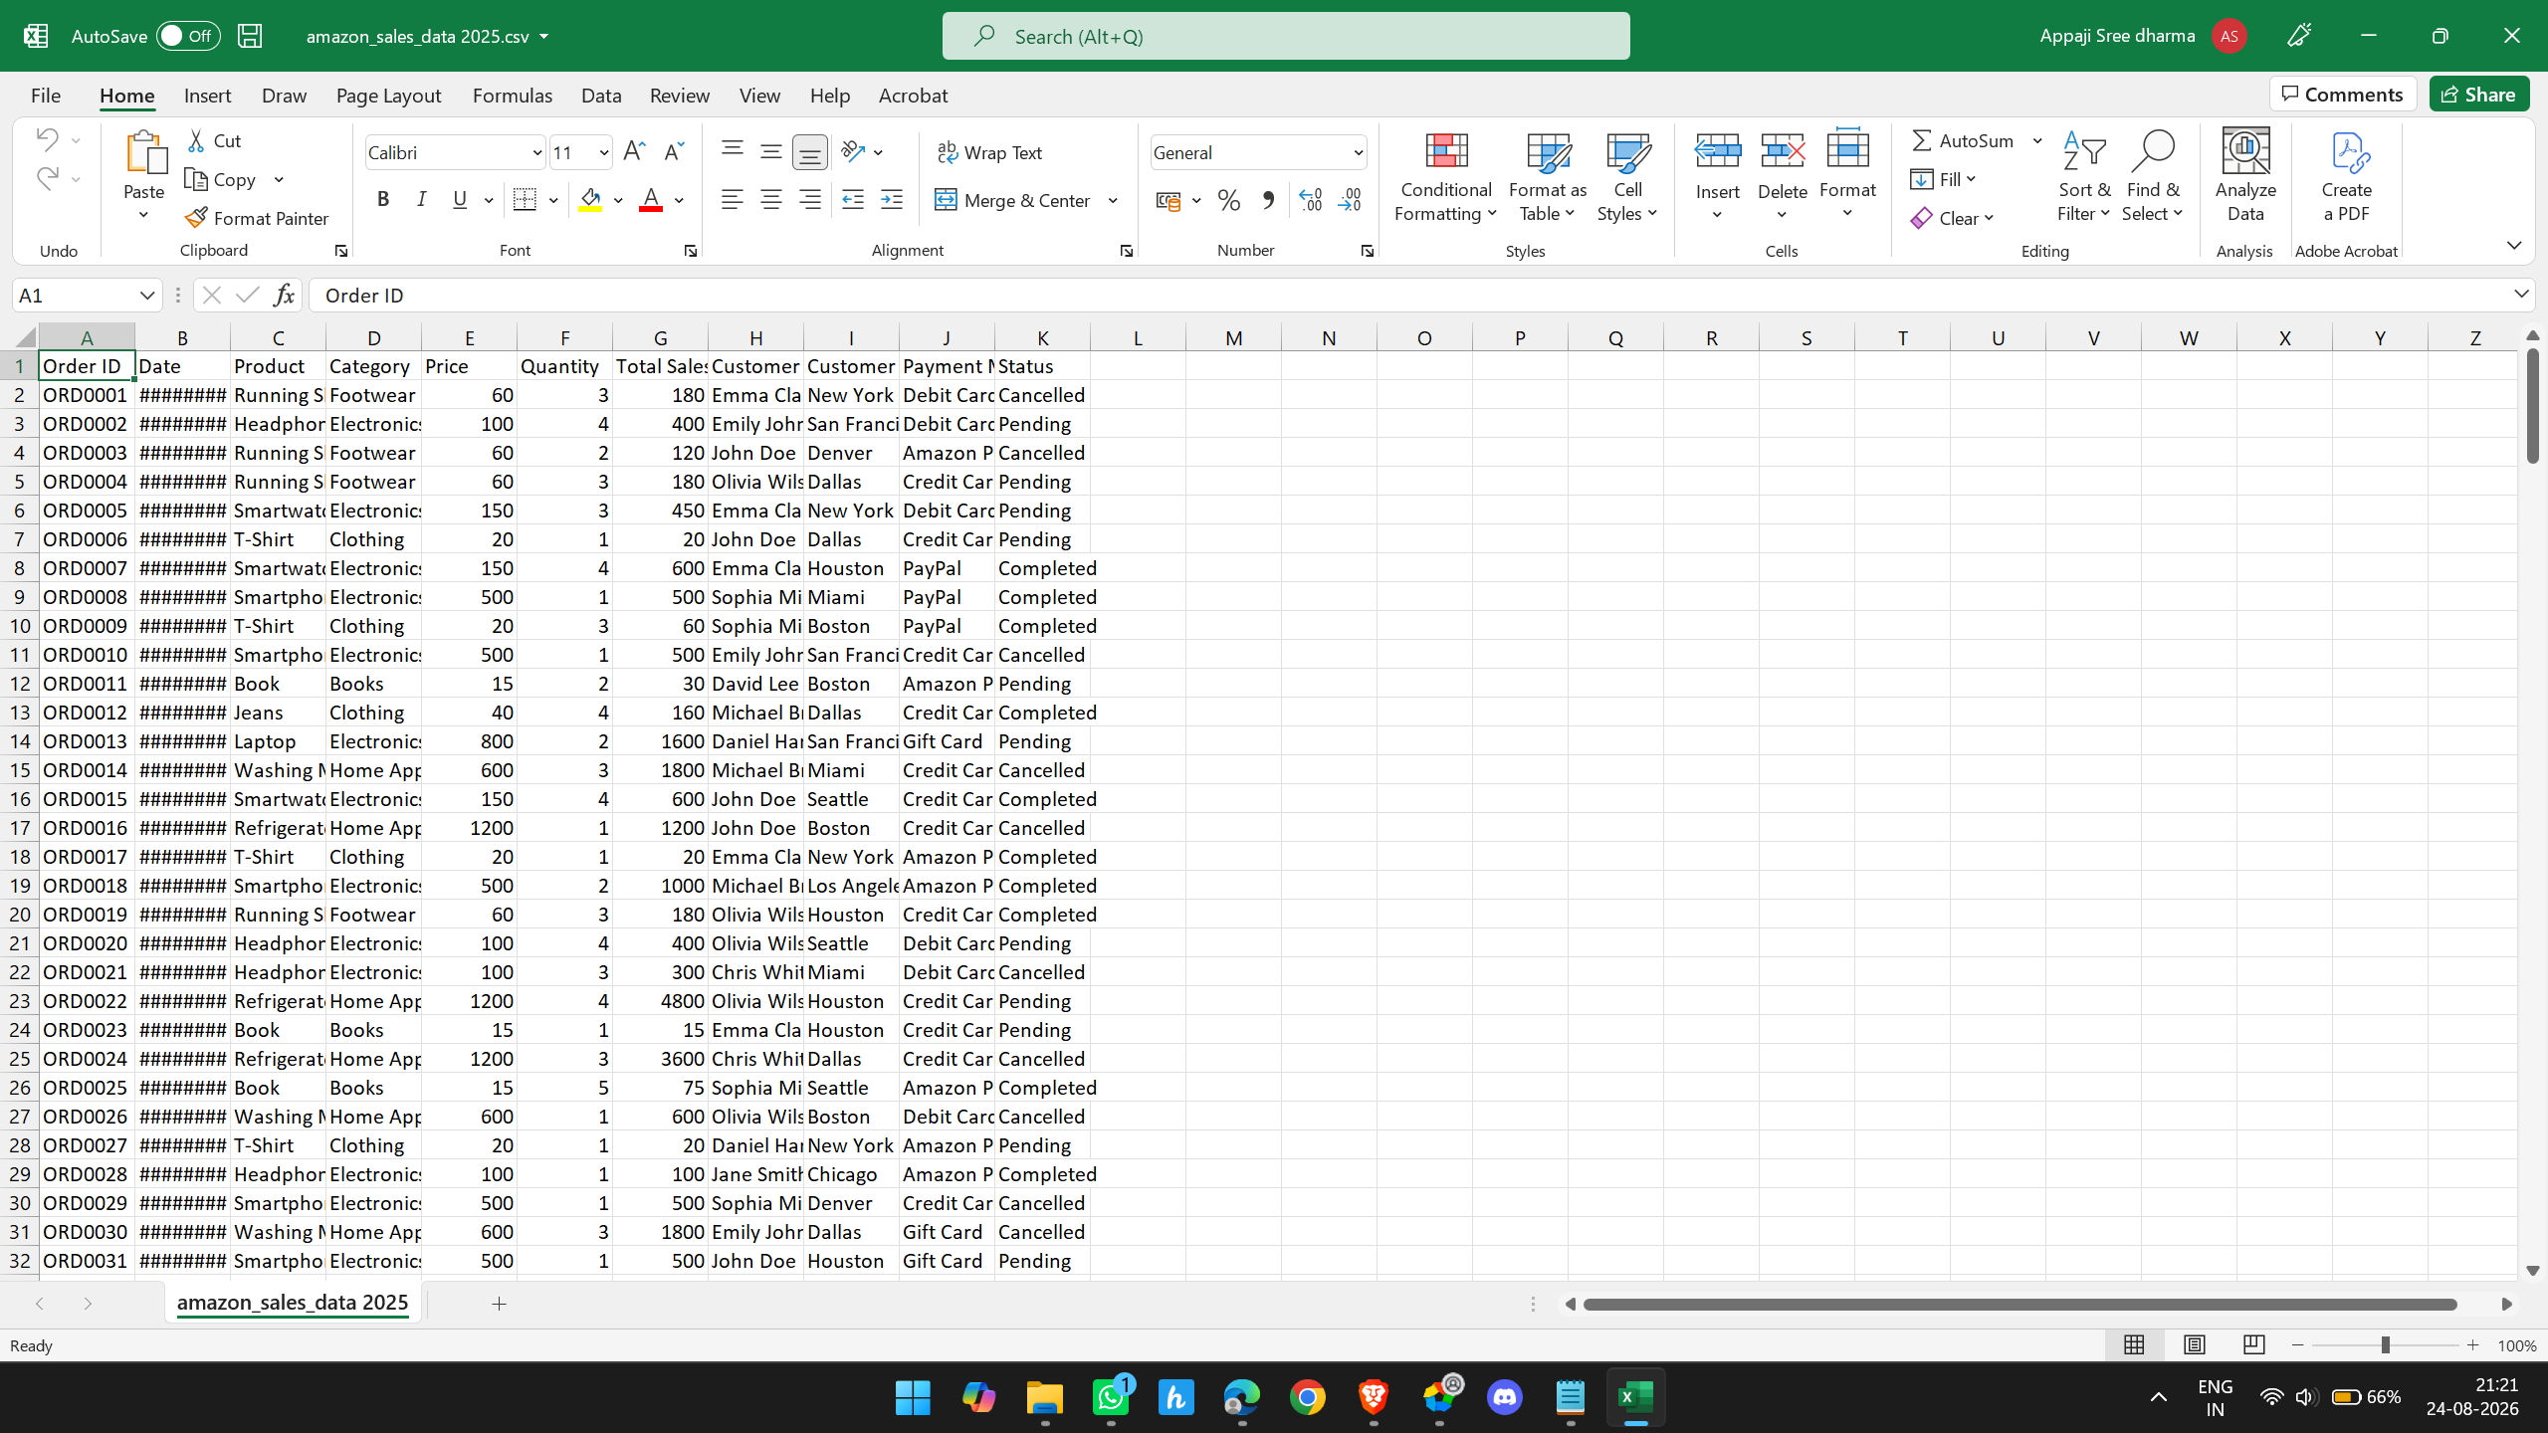
To not get the duplicates we have do this upto the rows 251 which includes the header so it is 250 rows of data only
2. Check missing values
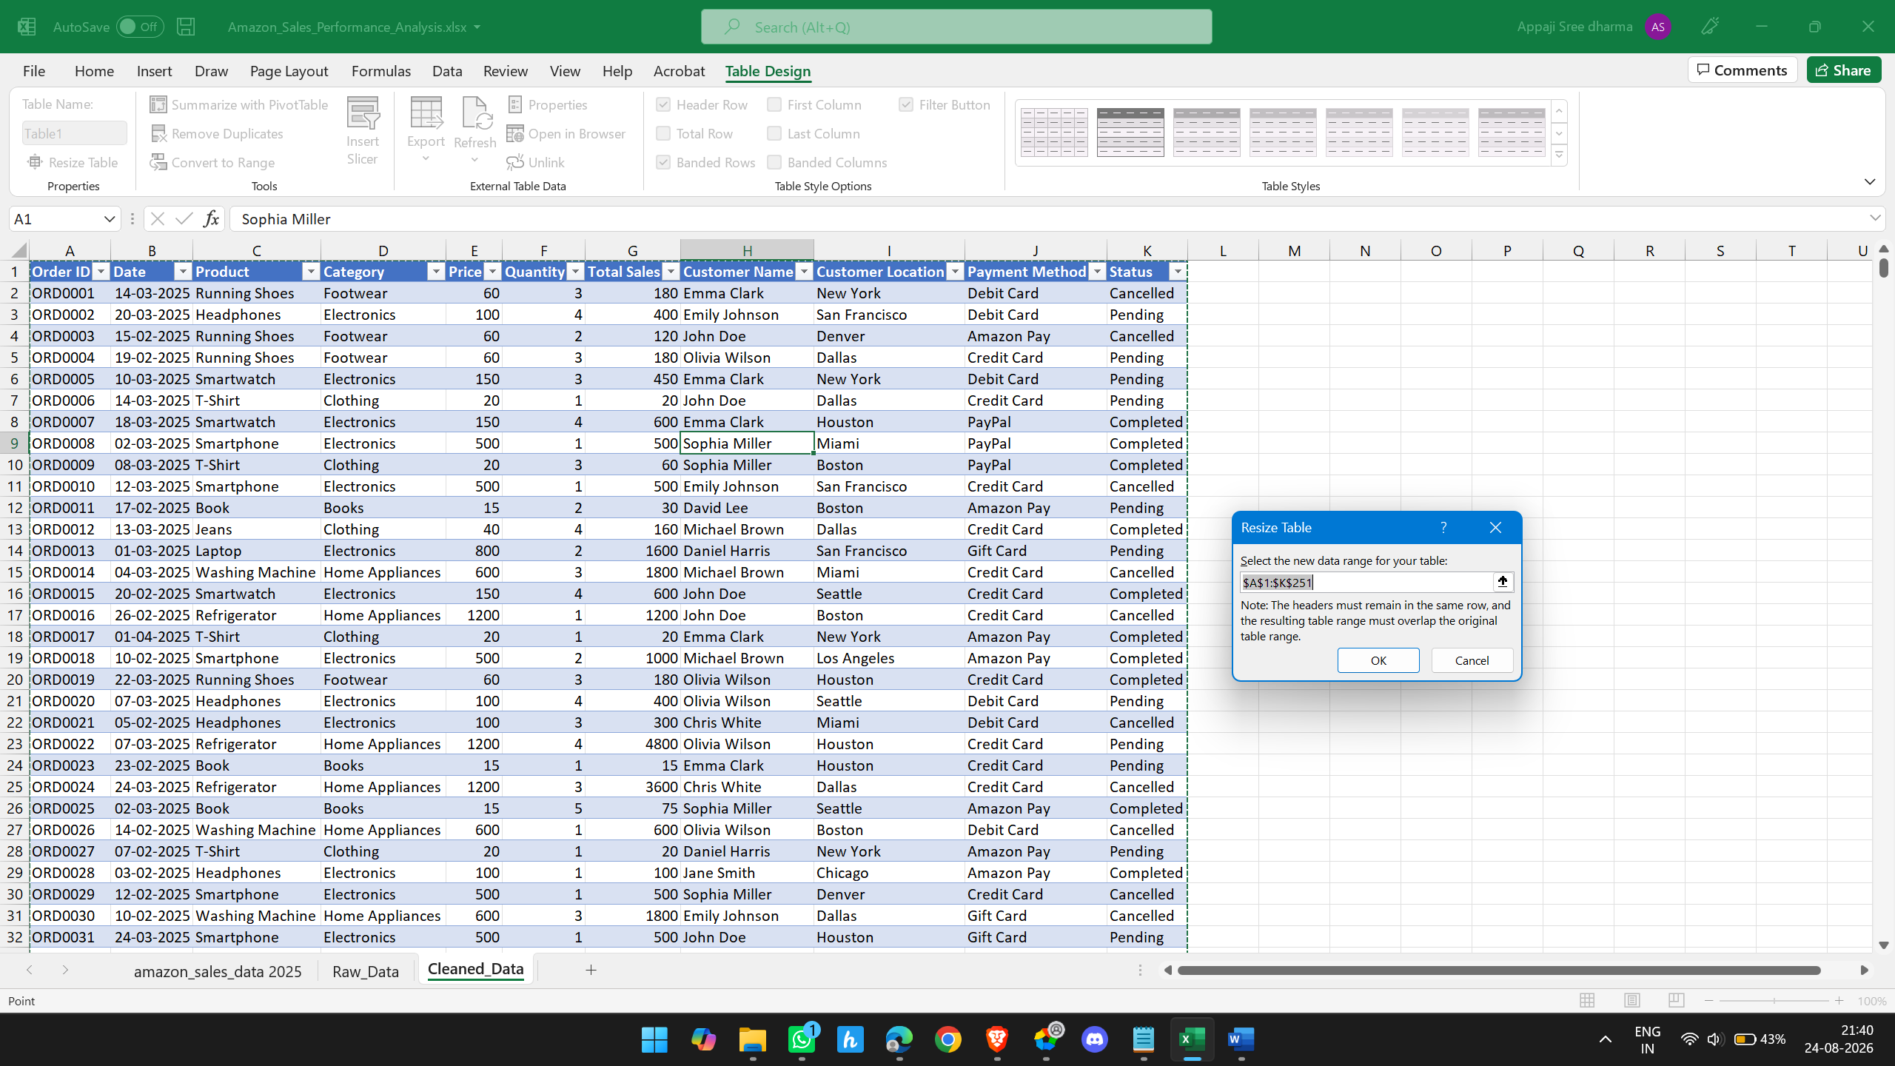

Here I have checked the data has duplicates or not using the remove duplicates if it has duplicates it will remove, if not it will show there are no duplicates.
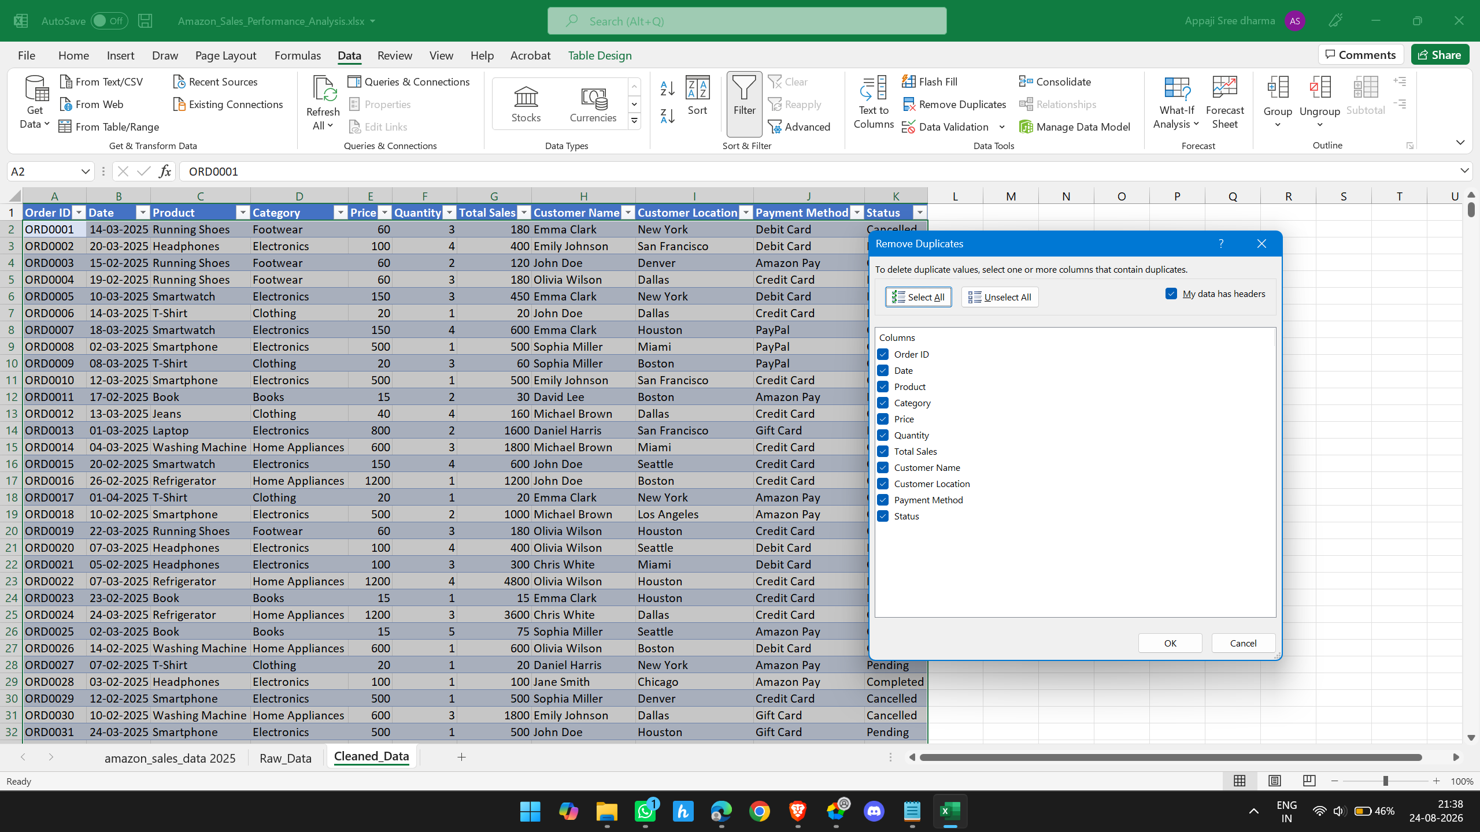
Now we have done checking the duplicates there are no duplicates but we have to check all columns attributes like
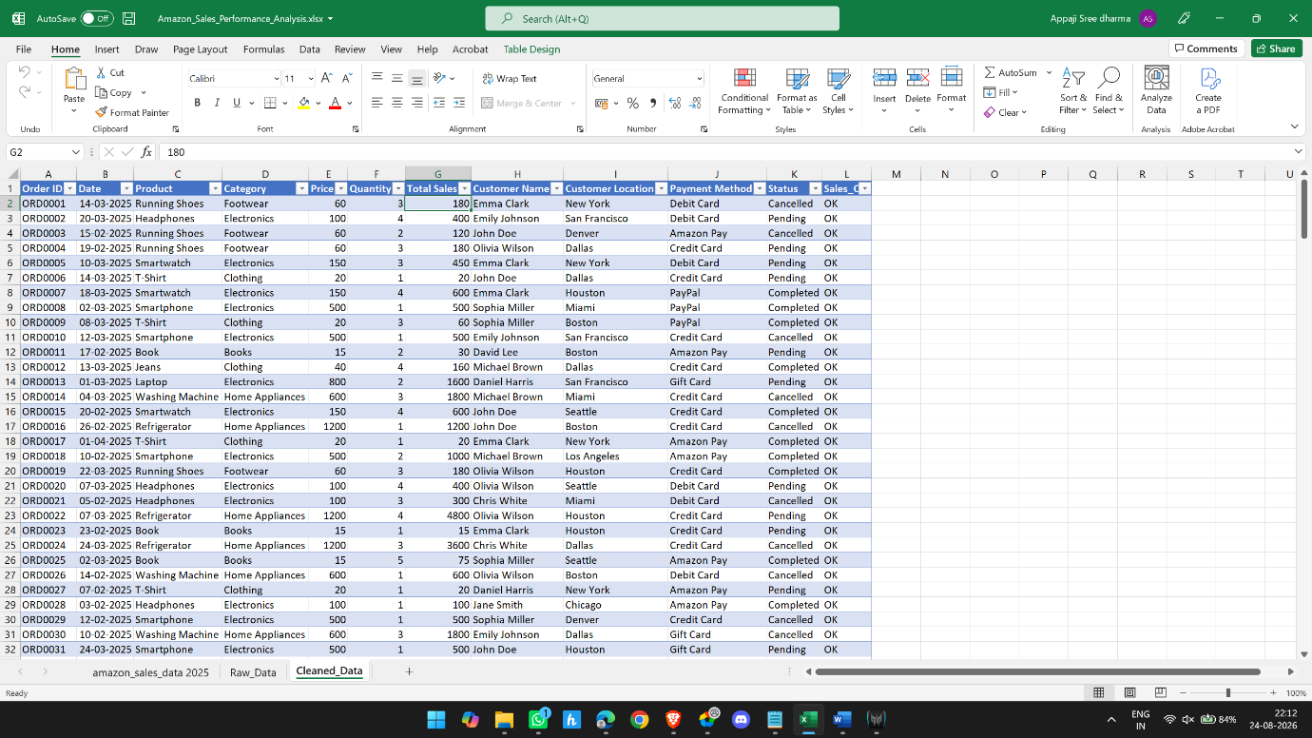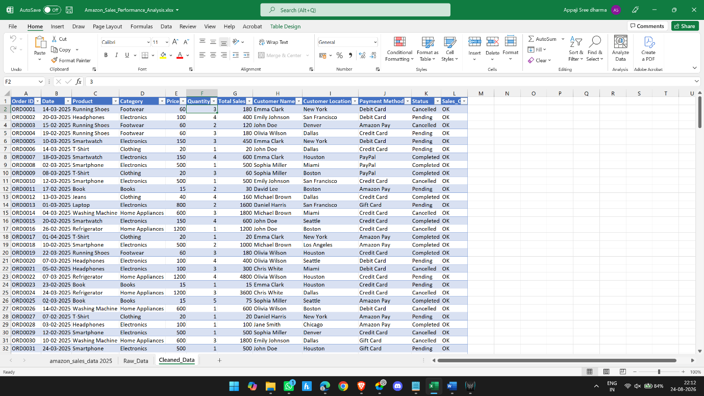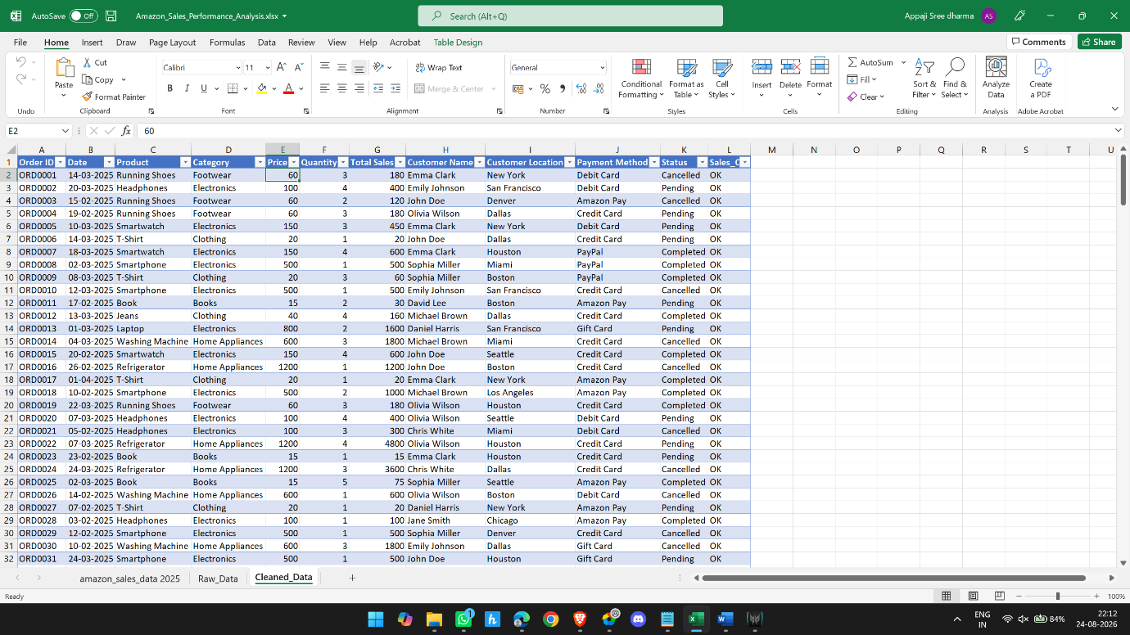

What we verified
Column | Values found | Result
Category | Books, Clothing, Electronics, Footwear, Home Appliances | ✅ Consistent
Customer Location | Boston, Chicago, Dallas, Denver, Houston, Los Angeles, Miami, New York, San Francisco, Seattle | ✅ Consistent
Payment Method | Amazon Pay, Credit Card, Debit Card, Gift Card, PayPal | ✅ Consistent
Status | Cancelled, Completed, Pending | ✅ Consistent
Customer Name | 10 customer names | ✅ Consistent
Product | 10 products | ✅ Consistent
Date | Feb, Mar, Apr 2025 | ✅ Valid
Price / Quantity / Total Sales | Numeric | ✅ Valid
Sales_Check | All OK | ✅ Valid

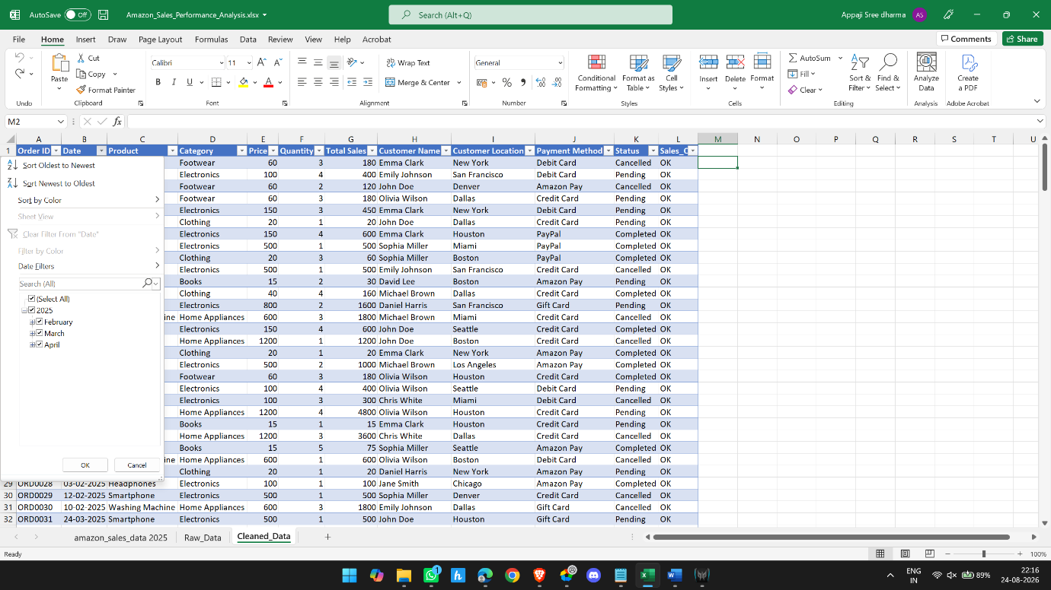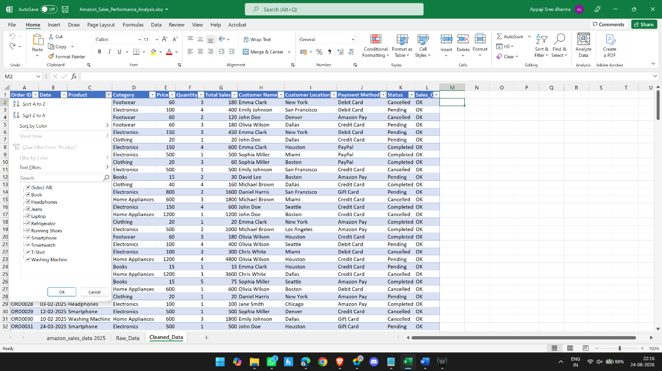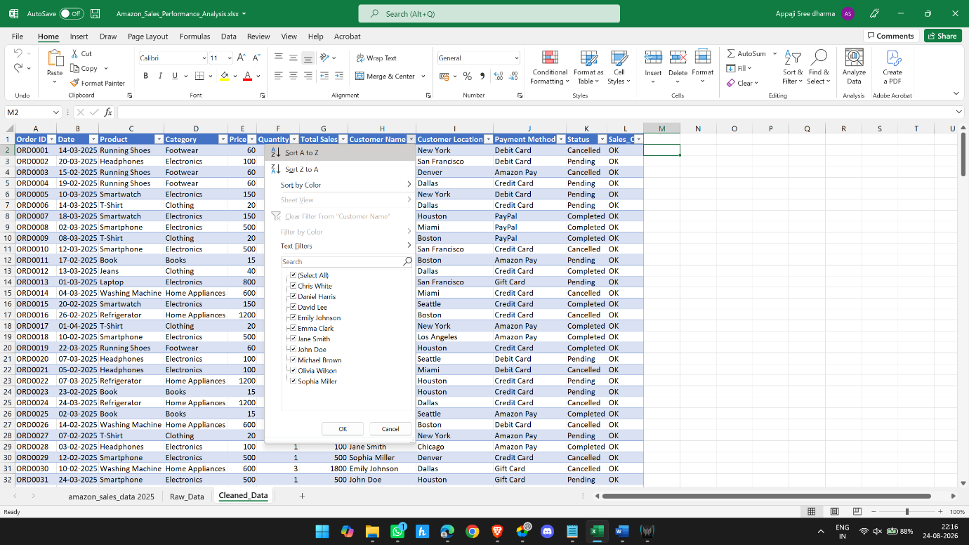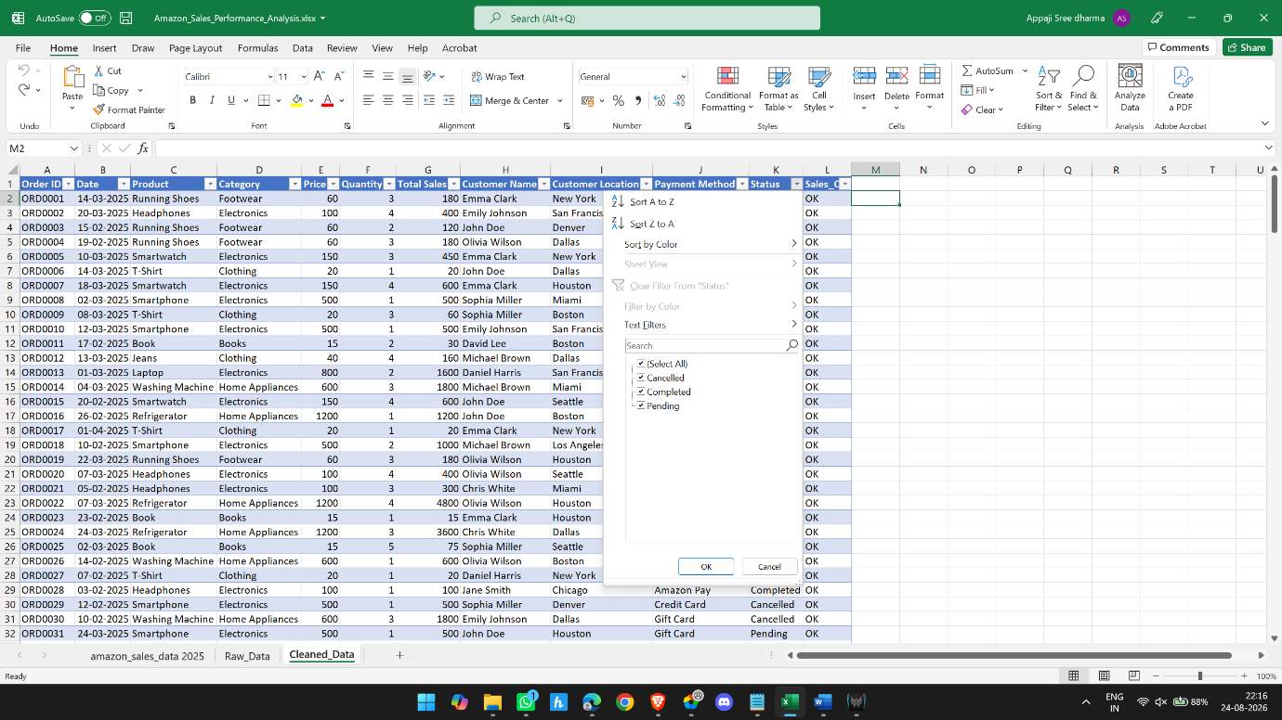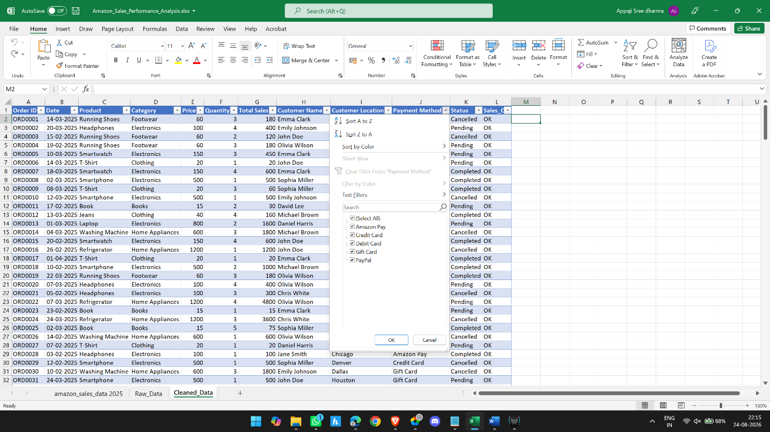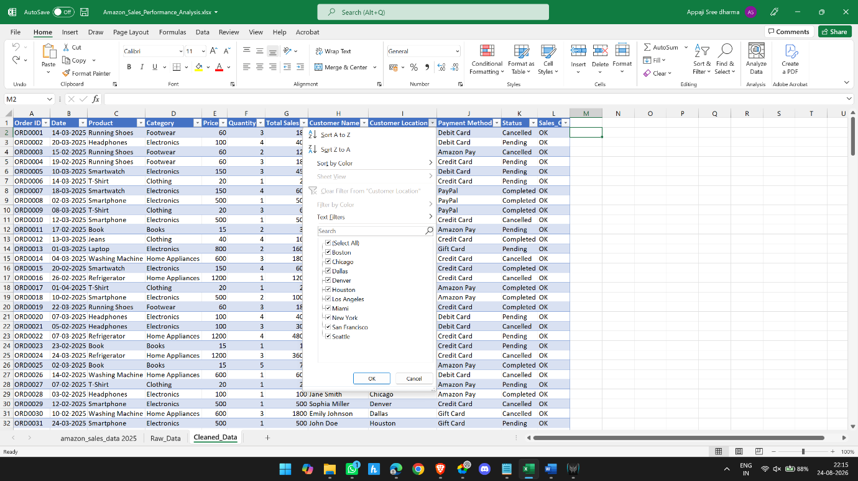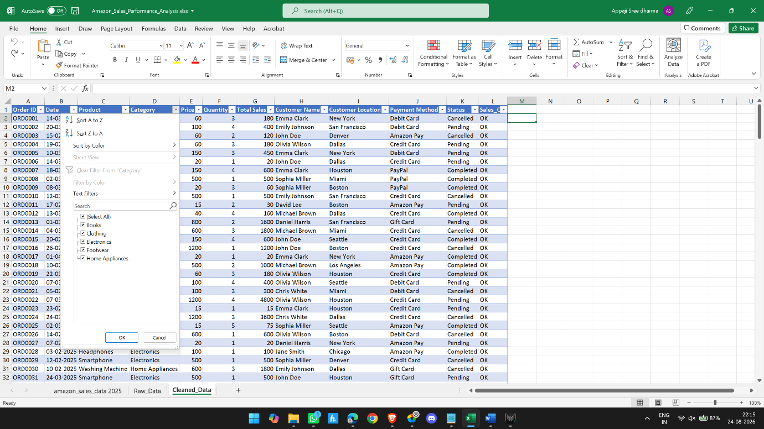

One important thing before PivotTables
Your project instructions specifically say:
Create calculated fields:
- Month
- Day of Week (optional)
- Order Status Flag
We should now do those.
But I want to make one improvement to your project structure:

Your current Cleaned_Data looks like this:
A: Order ID
B: Date
C: Product
D: Category
E: Price
F: Quantity
G: Total Sales
H: Customer Name
I: Customer Location
J: Payment Method
K: Status
L: Sales_Check
We'll add:
M: Month
N: Day of Week
O: Order Status Flag
This gives us a proper analysis-ready dataset.

Next: PivotTable Analysis
Now we move into the most important part of the project: turning the raw rows into business insights.
The project specifically asks for:
- Category-wise total sales
- Product-wise performance
- City-wise total sales
- Payment method usage
- Order status distribution
- Top customers by total spending
